Medical Director

Accessing Immunisation Information

**Note:** These steps assume that your software is connected to the My Health Record system, the patient has a My Health Record and their individual healthcare identifier (IHI) has been validated in your system.

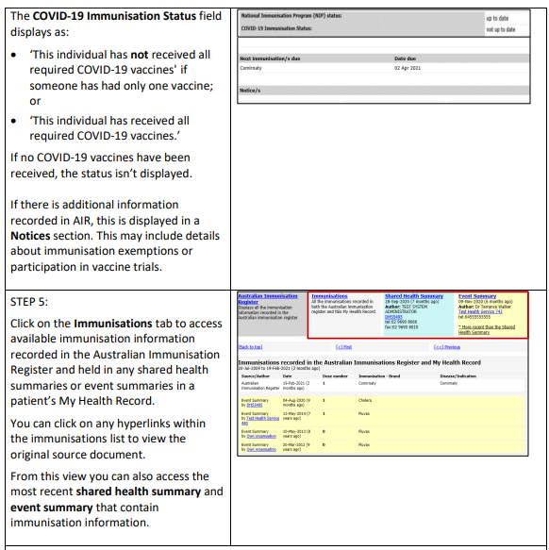

**Useful Links:**

* [How and when to view a My Health Record](https://www.myhealthrecord.gov.au/for-healthcare-professionals/howtos/view-my-health-record)
* [Upcoming training opportunities, events and webinars](https://www.digitalhealth.gov.au/newsroom/events-and-webinars)